Spectrum matching with LAI / CAB lookup

Purpose
Perform spectrum matching of individual image pixel spectra, comparing them with a spectral library. Find the closest match (least squares approach) and use the best match to find LAI and CAB values in a lookup table corresponding with the best found spectrum.

Installation
Install the .sav files in the save_add folder (see also ENVI .sav files: Installation and configuration.
nrsdata_CR_LAI_CAB.sav The data file containing CR, LAI, CAB
cablai_GUI.sav The software

Usage (command line)
nrs_cab_lai_estimate | Running the matching routine will try to find the ENVI variable file containing the spectral library and the LAI / CAB lookup tables; if this fails the software will ask for names of the variable files (CSV files, one for each variable).
nrs_cab_lai_estimate,crx,lai,cab | The spectral library (CRX) and the LAI / CAB lookup tables are provided by the user. This is the preferred way if the matching needs to be run more than once (the variables have to be loaded only once: just before calling this function).
To load the variables by hand, there are two options:
Double click the file with the variable data | Note: ENVI needs to be properly installed; the icon of the .sav file should look like
Run the command line:  restore, <full filename of variable file> | Fe: restore, ‘c:\envi42\save_add\nrsdata_CR_LAI_CAB.sav
For the software to recognize that the variables are loaded the existence of the CRX variable (spectral library) is checked: if this is available then the lookup tables are also assumed to exist. Note that besides the mentioned variables also the ALA and SRPLOT (table with 30 input spectra) variables are loaded.
When started, the software first will ask for an input image and then optionally for the variable file.

Usage (GUI)
Starting is possible from the command line:
CABLAI_GUI
, or from the ENVI menu ‘NRS | LAI/CAB match’, which starts the following dialog:
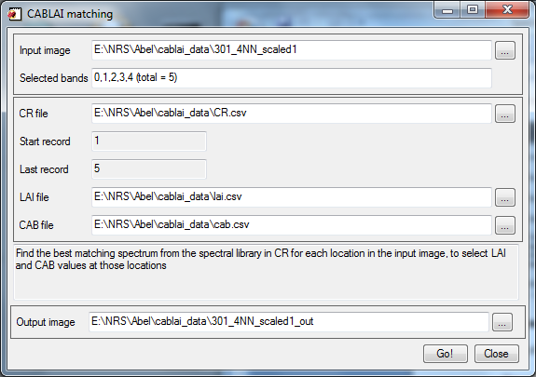
The software will think up an output name as soon as an input image has been selected.
The variable files are read from ASCII files, one for each variable (CR, LAI and CAB). When the CR file is selected, the software checks whether the LAI and CAB files are in the same folder and, if so, selects those automatically. It remains possible to select other files though.
When the software is running (both cases) a small progress indicator is visible:
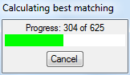
In case the GUI is used, some feedback is given with respect to the expected running time; this is visible in the info text field on the dialog.
When the progress indicator disappears a file has been written to disk in the same folder as the input image, with the same name, appended with ‘_out’ (command line version) or with the name specified in the dialog (GUI version). This file now contains three bands:
- Index :The index of the best spectrum in the spectrum library, and thus also into the lookup tables
- LAI : The value taken from the LAI lookup table at position index
- CAB : The value taken from the CAB lookup table at position index
If a match could not be found, the index will be -1 and values in the LAI and CAB bands will be NaN.

